

National College of Ireland

Project Cover Submission Sheet – 2020/2021

Student Name: | Rory G Cleary
Student ID: | x19139306
Programme: | Higher Diploma in Science in Computing (Software Development) | Year: | 2019/2021
Module: | Project
Lecturer: | Liam McCabe
Submission Due Date: | 28/08/21
Project Title: | MovieHats
Word Count: | ………………………………………………………………………………………………………………

I hereby certify that the information contained in this (my submission) is information pertaining to research I conducted for this project. All information other than my own contribution will be fully referenced and listed in the relevant bibliography section at the rear of the project.
ALL internet material must be referenced in the references section. Students are encouraged to use the Harvard Referencing Standard supplied by the Library. To use other author's written or electronic work is illegal (plagiarism) and may result in disciplinary action. Students may be required to undergo a viva (oral examination) if there is suspicion about the validity of their submitted work.

Signature: | 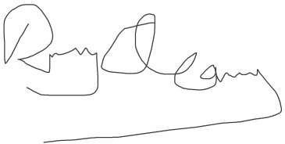
Date: | 28/08/21

PLEASE READ THE FOLLOWING INSTRUCTIONS:

1. Project deliverables should be submitted using the Upload Point from Moodle.
3. You must ensure that you retain a COPY of ALL projects' assets, both for your own reference and in case a project is lost or mislaid.
4. You must ensure that all projects are submitted to your Programme Coordinator on or before the required submission date. Late submissions will incur penalties.
5. All deliverables must be submitted and passed in order to successfully complete the year. Any project/assignment not submitted will be marked as a fail.

